Explain how to create CGI bin directory:
CGI stands for common gateway interface basically for a standard that provides an external gateway to interface servers.
Prerequisites: System we are working on should have an access to some local server. Here I am using apache2.
The following command will install the latest meta package apache2.
sudo apt update
sudo apt install apache2

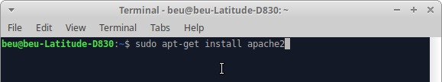
Goal: Creating a CGI bin directory and allow CGI to get the apache server to recognize the directory which we have created and to allow the same for the execution of commands from within that directory.
Construction:
Step 1: Creating it with the command sudo mkdir /usr/lib/cgi-bin would create a cgi-bin directory within the /usr/lib/ directory. This is where our Python programs and other various files will be placed. Generally, it is the repository for our executables.
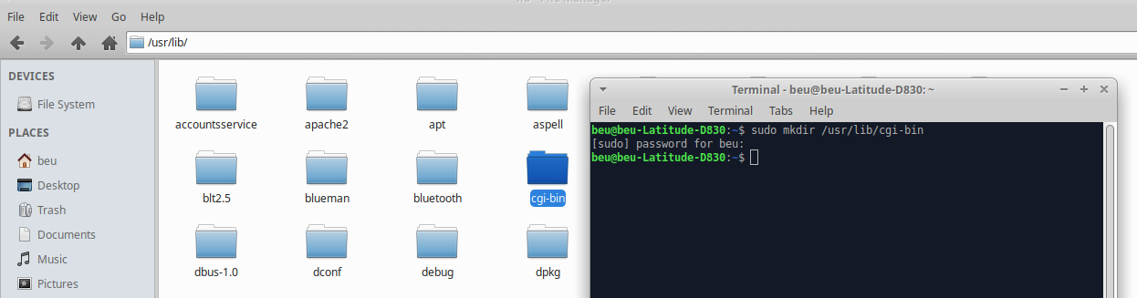
Step 2: Issuing the sudo chmod 755 /usr/lib/cgi-bin command to provide write permission only for the owner and read/execute permission for others and sudo chown root.root /usr/lib/cgi-bin to sets the user and group of cgi-bin to root.

Step 3: The command ls -l /usr/lib can be used to check our directory's permissions.
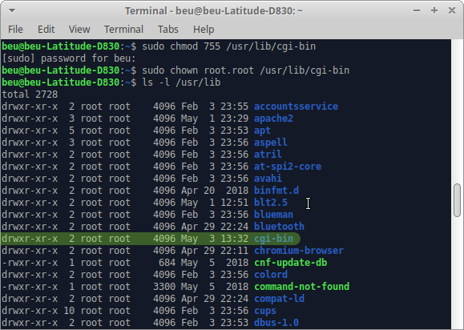

Step 4: Activating the VirtualHost Configuration File by adding the following line in the file /etc/apache2/sites-available/000-default.conf

ScriptAlias /cgi-bin/ /usr/lib/cgi-bin/
<Directory "/usr/lib/cgi-bin">
AllowOverride None
Options +ExecCGI -MultiViews +SymLinksIfOwnerMatch
Order allow,deny
Allow from all
</Directory>
By doing so, apache will now know about CGI and where its directories are located.
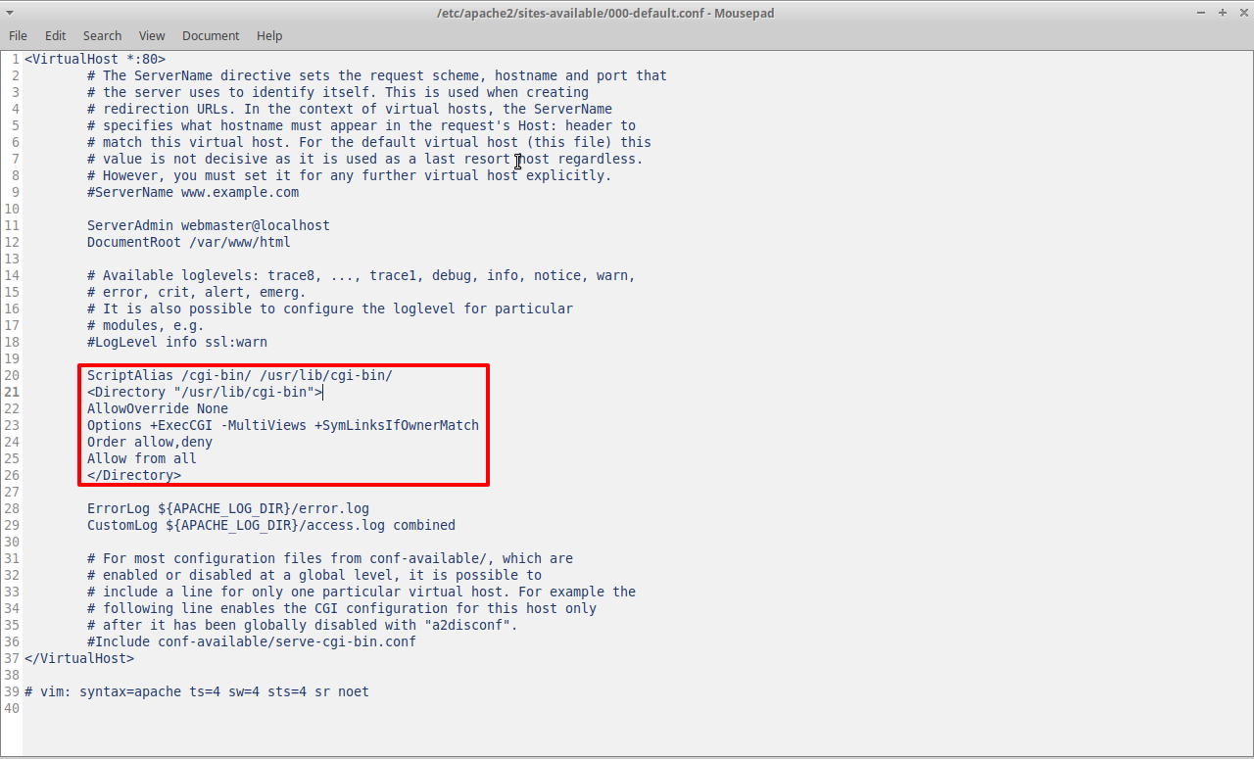

Now our cgi-bin directory is ready.

Implement the hello world program in CGI fashion using python.
Step 1 : Creating a python script as following.
#!/usr/bin/python
print("content-type:text/html\r\n\r\n")
print("<html>")
print("<head>")
print("<title>My very first CGI</title>")
print("</head>")
print("<body>")
print("<h1>HELLO WORLD !</h1>")
print("</body>")
print("</html>")
Step 2 : Saving the above python script file in /usr/lib/cgi-bin as hello_world.py and giving it 755 permissions (means read and execute access for everyone and also write access for the owner of the file).
This can be achieved by giving the command sudo chmod -R 755 /usr/lib/cgi-bin/hello_world.py
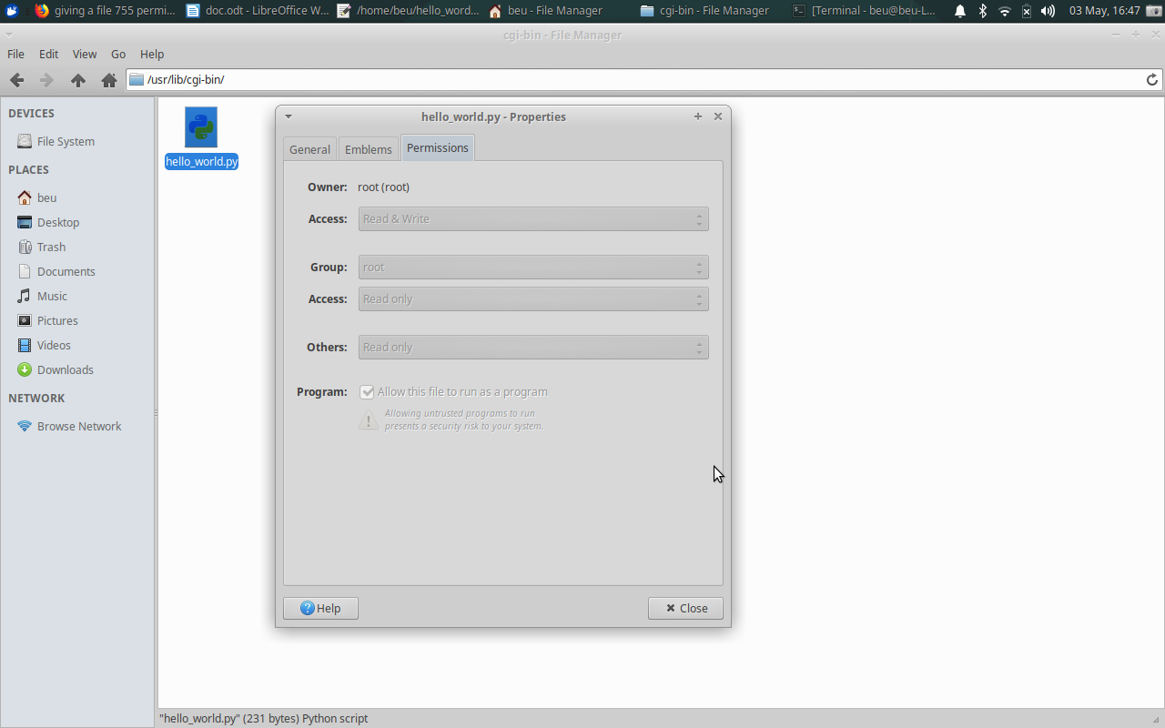

Step 3 : Start apache2 server by issueing the command sudo service apache2 start.
Step 4 : Opening that file in web browser by pointing it to http://localhost/cgi-bin/hello_world.py
